Riphah Journal of Islamic Thought & Civilization
(RJITC)

Bi-Annual Journal
January- June 2026, Vol:IV, Issue: I

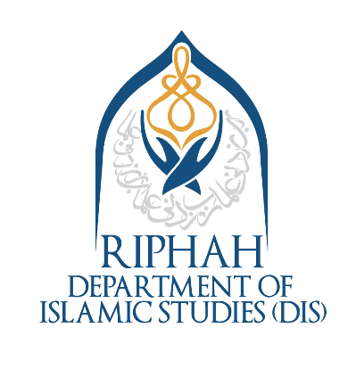

Editor-In-Chief

Dr. Ikram Ul Haq

Editor

Dr. Inam ul Haq

Department of Islamic Studies,
Riphah International University, Islamabad, Pakistan.
Block- F, Sector I-14, Hajj Complex, Islamabad, Pakistan.
Tel: +92-51-8446000-08, Ext # 380 Fax: +92 (51) 831 3141
Email: editor.rjitc@riphah.edu.pk, Website: https://journals.riphah.edu.pk/index.php/jitc

Editorial Team
Patron-in-Chief
Mr. Hassan Muhammad Khan
Chancellor, Riphah International University, Islamabad, Pakistan
Patron
Prof. Dr. Anis Ahmed
Vice-Chancellor, Riphah International University, Islamabad, Pakistan
Editor-in-Chief
Dr. Ikram Ul Haq
Head, Department of Islamic studies, Riphah International University, Islamabad, Pakistan
Editor
Dr. Inam ul Haq
Assistant Professor, Department of Islamic Studies, Riphah International University, Islamabad, Pakistan
Associate Editors
- Dr. Muhammad Kashif Sheikh (Arabic Language), Associate Professor, Department of Islamic Studies
- Dr. Hafiz Munir Ahmed, (Arabic Language), Assistant Professor, Department of Islamic Studies
- Dr. Zabih Ur Rahman, (Urdu Language), Assistant Professor, Department of Islamic Studies
- Dr. Muhammad Ghayas, (Urdu Language), Assistant Professor, Department of Islamic Studies
- Dr. Shehla Riaz, (English Language), Assistant Professor, Department of Islamic Studies
- Dr. Farman Ali, (English Language), Assistant Professor, Department of Islamic Studies
Editorial Assistant
Ms. Fariha Fatima, Senior Lecturer, Department of Islamic Studies.
Technical Assistant
Mr. Adnan Sami Khan, Program Executive, Department of Islamic Studies.

Advisory Board

Advisory Board International
Prof. Dr. Muhammad Abdalla, Director, Center of Islamic Thought and Education, University of South Australia, Australia
Prof. Dr. Mehmet Ozsenel, Faculty of Hadith, Marmara University, Turkiye
Prof. Dr. Abdulhamit Birışık, Faculty of Ilahiyat , Marmara University, Turkiye
Prof. Dr. Mohd. Mumtaz Ali, Faculty of Islamic Revealed Knowledge and Human Sciences, International Islamic University, Malaysia
Prof. Dr. Mohd Roslan Bin Mohd Nor, Department of Islamic History and Civilization, Academy of Islamic Studies, University of Malaya, Malaysia
Prof. Dr. Mohamed Hamadikinane Kinane Maiga, Faculty of Shariah & Law, Sultan Sharif Ali Islamic University, Brunei Darussalam, Brunei
Prof. Dr. Samira Hida, Mohamed First University, Oujda, Morocco Dr. Salih Yucel, Associate Professor, Centre for Islamic Studies and Civilization, Charles Sturt University, Sydney, Australia Dr. Aamir Jamal, Associate Professor, Faculty of Social Work, University of Calgary, Canada

Advisory Board National
Prof. Dr. Qibla Ayaz, Chairman, Council of Islamic Ideology, Islamabad, Pakistan Prof. Dr. Abdul Quddos Suhaib, Chairman, Department of Islamic Studies, Bahauddin Zakria University, Multan, Pakistan Prof. Dr. Muddassir Ahmed, Chairman, Riphah International University, Faisalabad Campus, Pakistan Prof. Dr. Mustafeez Ahmed Alvi, Dean, Faculty of Social Sciences, National University of Modern Languages (NUML), Islamabad, Pakistan Dr. Alam Khan, Associate Professor, HOD, Seerah Chair & Islamic Studies, Shifa Tameer-E-Millat University, Islamabad

